Draft 3

Camera for Venus Express
Proposal for experiment

Science Team

Principal Investigator:
Dr. H.U. Keller, Max-Plank-Institut fr Aeronomie, Germany

Co-Investigators:
Dr. W.J. Markiewicz, MPAe, Germany
Dr. N. Thomas, MPAe, Germany
Dr. D.V. Titov, MPAe, Germany
Prof. F.W. Taylor, Oxford University, UK.
Dr. E. Lellouch, DESPA, Observatoire de Meudon, France
Prof. L. Esposito, LASP, Colorado, USA
Prof. D. Crisp, JPL, NASA, USA
Dr. N. Ignatiev, Space Research Institute (IKI), Moscow, Russia
Prof. K. Oyama, ISAS, Japan

Table of Content
1. Introduction 4
2. Scientific objectives 6
2.1 Daytime observations in the UV-blue spectral range 6
2.2 Observation of the UV and visible airglow at the nightside 7
2.3 Surface and lower atmosphere emission in the 1 μm transparency “window” 8
2.4 Complementarity to the Venus Express core payload 10
3. Camera performance and design 11
3.1 Spectral properties 11
3.2 Angular resolution requirements 14
3.3 Camera design 14
3.3.1 CCD detector 14
3.3.2 Optical scheme 15
3.3.3 Temperature requirements 15
3.3.4 Instrument resources 15
3.3.5 Experimental heritage 15
3.4 Observations at Venus 16
4 Management and planning 16
4.1 Cost estimates 16
4.2 Planning and responsibilities 16
5. Team experience 16
References 18

Introduction
The Venus Express mission will focus on the global investigation of the Venusian atmosphere and plasma environment from orbit and address some important aspects of geology and surface physics. The core payload of this mission is composed of instruments available from the Mars Express and Rosetta projects. They are: SPICAM – a versatile UV-IR spectrometer, PFS – a high-resolution IR Fourier spectrometer, ASPERA – a combined energetic neutral atom imager, electron and ion spectrometer, VIRTIS – a sensitive visible spectro-imager and mid-IR spectrometer, and radio science experiment VeRa. These experiments cover the majority of the Venus Express scientific goals. In addition, more than ten additional instruments were proposed in order to complement the core payload and improve the scientific outcome of the whole mission.
The wide-angle camera is in the list of complementary payload for Venus Express. One of the main goals of the Venus Express mission is to study the dynamics. This objective requires global imaging of the planet. However the mapping capabilities of the core payload set are rather limited. The only imaging instrument (VIRTIS) has a field of view of ~1° that is far too narrow to observe the global pattern of atmospheric motions. Complete coverage of the planet’s disc by this experiment would require complicated spacecraft operations (re-pointing). A lightweight wide-angle (FOV~ 30°) camera is needed onboard Venus Express to achieve this core scientific goal properly.
The present proposal describes such a camera that will take images of Venus in six filters from UV to near-IR with spatial resolution from 0.25 km to 30 km depending on the distance from the planet. The full disc of Venus will be in the FOV near the apocenter of the orbit. The camera will complement the core experiments of Venus Express 1.) by tracking cloud motions at ~67 km (cloud tops) and at ~50km (main cloud); 2.) by mapping O₂ and NO nightglow and its variability that are optical tracers of the thermospheric dynamics (110-150 km); 3.) by mapping the nightside thermal emission from the surface and studying of the lapse rate and H₂O content in the lower 6-10 km. In addition the camera will provide imaging context for the whole mission and its movies will be of significant interest for the public and scientific outreach programme. Moreover, the same instrument will be proposed for the Japanese Venus Orbiter.

2. Scientific objectives
A simple camera using CCD detectors with a sensitivity range from 0.2 to 1.0 μm will achieve the scientific goals described below. The main focus of this experiment will be to observe the dynamical phenomena in the Venus atmosphere in the altitude range from thermosphere (~150 km) to the main cloud deck (~50 km).

2.1 Daytime observations in the UV-blue spectral range
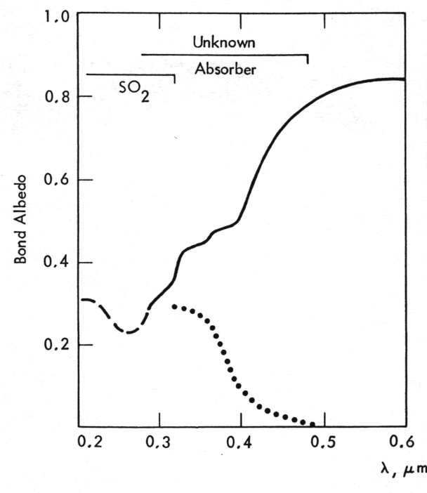
Figure 2.1. UV-visible spectrum of Venus’ spherical albedo (solid) and contrasts (dots).
The spectrum of solar radiation reflected by Venus has broad absorption feature between 0.2 and 0.5 μm (Fig. 2.1) (Moroz, 1985). The region between 0.2 and 0.32 μm is well explained by the presence of SO₂ at the cloud tops. The spectrum above 0.32 μm implies the presence of another absorber that has not been identified so far. The problem of the second UV-blue absorber at the cloud tops is one of the most important puzzles in the chemistry of the Venus atmosphere and cloud layer. Identification of the absorber is also important because due to this species Venus absorbs about 50% of solar radiation at the cloud top level. This has important implications for the energy balance and dynamics of the whole atmosphere.
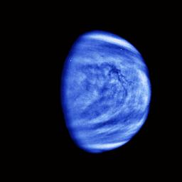
Figure 2.2. Gallileo image of Venus in the UV.
Inhomogeneity in spatial and/or vertical distribution of the unknown absorber produces the famous UV features on the Venusian disc (Figure 2.2). Tracking their motions has been usually used to study the dynamics of the cloud tops, i.e. to measure the winds and observe the wave phenomena. The typical size of the UV features does not exceed 100 km. Their motions mark the superrotation of the Venus cloud tops at ~67 km altitude with zonal velocity of about 100 m/s and ten times slower meridional speed.
The imaging of Venusian disc at several wavelengths between 0.2 μm and 0.5 μm has the following scientific objectives:
- Study of spatial and vertical distribution of the UV-blue absorbers at the cloud tops;
- Study of correlation between SO₂ and unknown absorber that would help to identify the latter;
- Study of the dynamics of cloud tops by tracing the motions of UV features;
- Study of the vertical distribution of haze above the main cloud layer.

2.2 Observation of the UV and visible airglow at the nightside
Several types of airglow were observed on the Venus nightside. The spectrometer experiment onboard Venera-9 and -10 discovered strong airglow in the visible (Krasnopolsky, 1983). Figure 2.3 shows the airglow spectrum that led to the unambiguous identification of the Herzberg I and II systems of O₂ with a total intensity of ~3 kR. Limb observations showed that this emission originates in a layer at 90-110 km altitude.
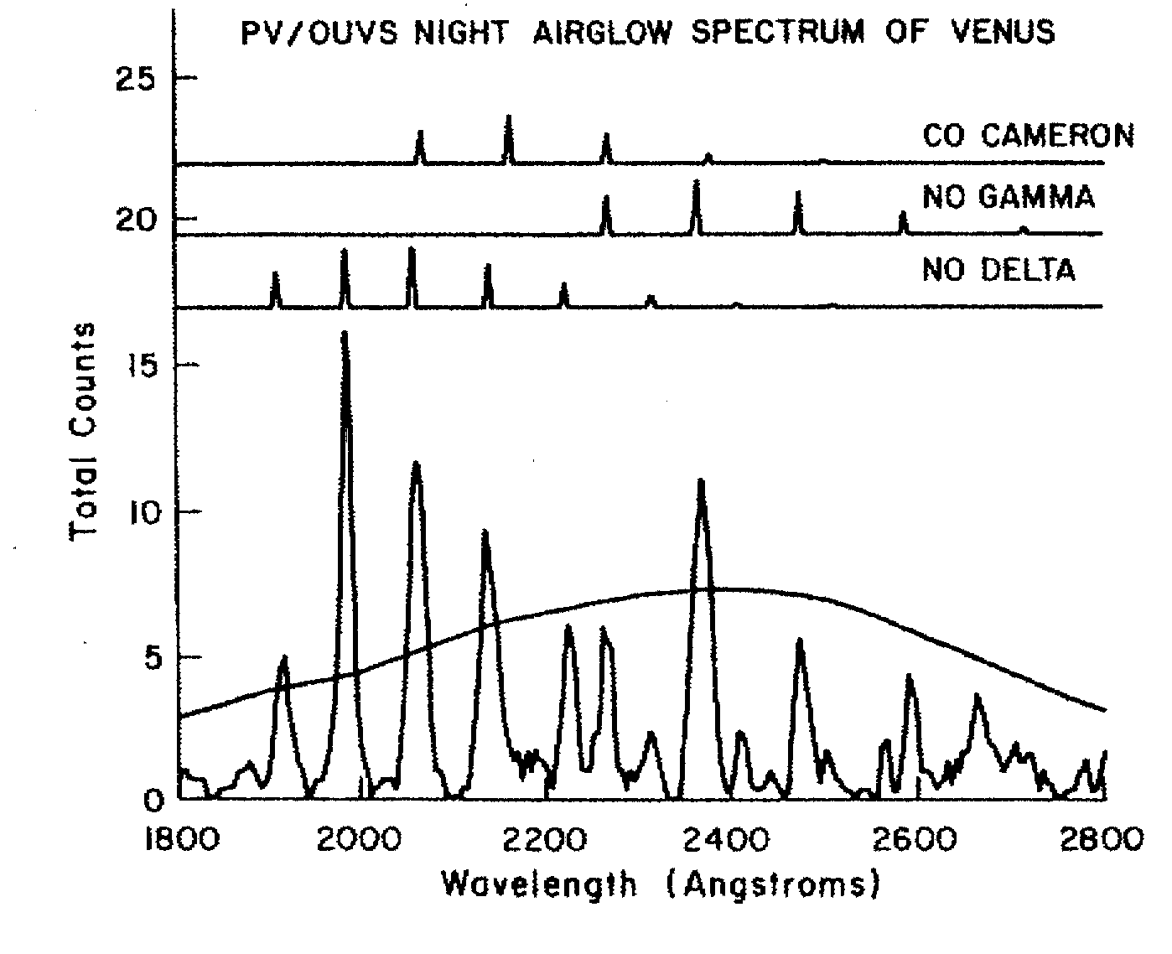
Figure 2.4. Spectrum of the night NO airglow.
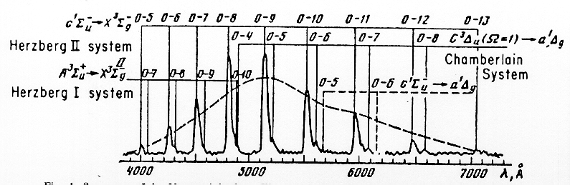
Figure 2.3. Spectrum of the O₂ nightside airglow
The other night emission was observed by the Pioneer Venus UV spectrometer (Stewart et al., 1980). This airglow was identified with NO bands (Figure 2.). It originates at slightly higher altitudes (110-150 km) in the thermosphere.
Both airglows have similar excitation mechanism. The atoms of O and N are produced on the dayside by photolysis. The general circulation of the thermosphere (100 –180 km) has mainly solar-antisolar direction. It transports the products of dissociation to the nightside where they recombine resulting in formation of excited O₂ and NO molecules which emit characteristic spectral lines. The spatial distribution of the airglow pattern on the nightside is thus very sensitive to the thermospheric circulation and can be used to trace the atmospheric motions at these altitudes. Figure 2.5 shows the images of the O₂ nightglow at 1.27 μm. Its origin is similar to that of the visible emissions shown in Fig. 2.3. Observations of the O₂ emissions show a pronounced maximum at the nightside around midnight. The emission pattern strongly varies both in space and time indicating fast changes in the thermospheric circulation (see Fig. 2.5).
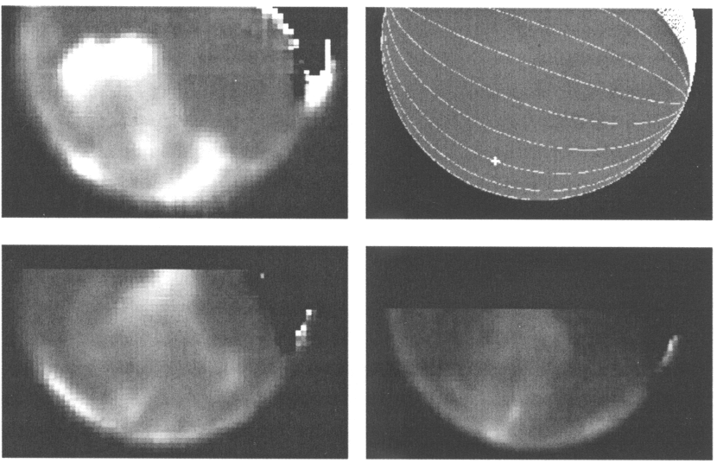
Figure 2.5. Images of the Venus nightside airglow at 1.27 μm (Crisp et al., 1996)
Mapping the airglow spatial distribution and its temporal variations will significantly contribute to the study of the circulation of the lower thermosphere (100-130 km). Limb imaging will be used to study the high altitude haze layers. In addition these observations will also continue the search for lightning.

2.3 Surface and lower atmosphere emission in the 1 μm transparency “window”
The discovery of spectral “windows” in the near IR spectrum of Venus (Allen and Crawford, 1984), through which thermal radiation from the hot lower atmosphere and even surface can leak to space, provide a powerful tool to study the atmosphere below the clouds. These weak emissions can be observed only on the night side of the planet. Figure 2.6 shows a synthetic spectrum of the Venus nightside (Ignatiev, private communication) together with that measured by the VIMS instrument during the Cassini fly-by (Baines et al., 2000). Groundbased observations and subsequent radiative transfer modeling show that the 1 μm “window” emission originates at the surface (Meadows and Crisp, 1996). The thick atmosphere and cloud layer contribute only to conservative scattering of the radiation but not to emission.
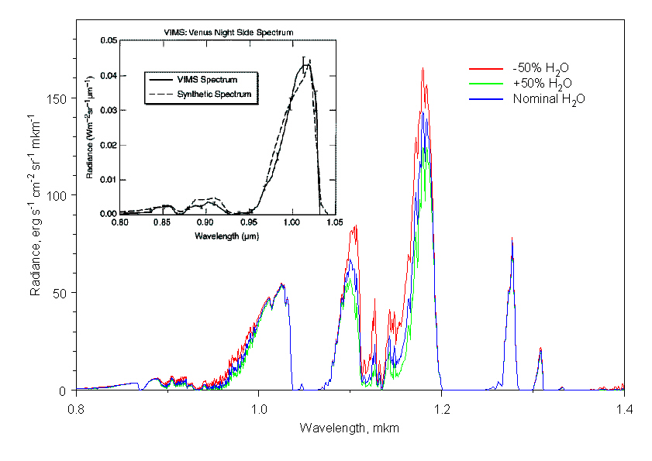
Figure 2.6. Synthetic spectrum of the sub-micron radiation from the Venus nightside and Cassini/VIMS measurements of the 1μm emission.
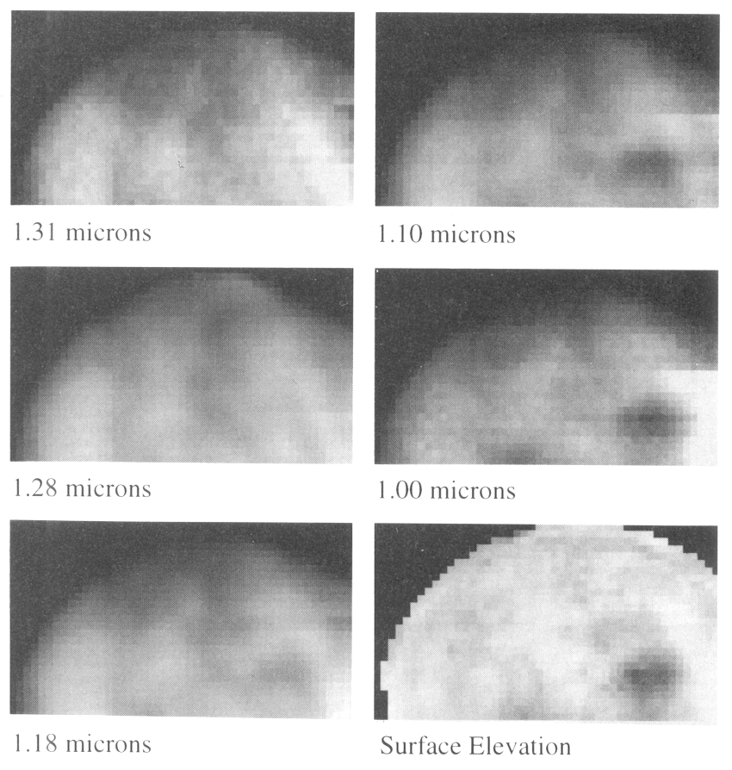
Figure 2.7 Ground-based observations of the Venus nightside in sub-micron transparency “windows”.
Imaging the Venus nightside at 1 μm would yield the spatial distribution of the surface brightness temperature attenuated by diffuse scattering in the atmosphere and cloud layer. Figure 2.7 shows the ground-based images of Venus obtained in different “windows” shown in Fig. 2.6. (Meadows and Crisp, 1996). At 1.31, 1.28, and 1.18 μm the atmospheric emission prevails and the brightness pattern is due to inhomoheneities of the cloud opacity. Tracking the motions of these features would characterize the wind speeds at ~50 km altitude. At shorter wavelengths (1.1, 1.0 μm) the surface emission becomes dominant and brightness distribution correlates with topography: the higher the region the darker it appears on the image. This adds the pattern of surface origin to that defined by the clouds (see Fig. 2.7). Thus a sequence of such images taken from orbit can provide information on both the surface and cloud layer. Moreover, Meadows and Crisp 1996 showed that the mapping in 1 μm window could be effectively used to derive the lapse rate in the lower 6 km.
Figure 2.6 shows that the shortwavelength side of the 1μm emission peak is sensitive to the water vapour abundance in the lower atmosphere. Thus mapping the emission at ~0.97 μm in addition to 1 μm could yield the global distribution of the water vapour in the lower scale height.
To summarize, the scientific goals of the Venus Express camera observations in the near IR are the following:
- Mapping the surface brightness temperature distribution;
- Search for “hot spots” associated with volcanic activity;
- Search for emissivity anomalies and their correlation with radar images;
- Determination of the lapse rate in the lower 6-8 km of the atmosphere;
- Determination of the H₂O global distribution in the lower 10 km;
- Study of the circulation of the main cloud deck;
- Monitoring the atmospheric column opacity and its variations.

Complementarity to the Venus Express core payload
The atmospheric remote sensing set of Venus Express core payload consists of three powerful spectrometers. One of them – VIRTIS- has imaging capabilities. However the VIRTIS field of view of ~1° is far too narrow to take images of the whole disc of Venus and to monitor global dynamical processes. The proposed wide-angle camera would provide the imaging context for the whole mission and will fulfil the important task of global monitoring of the atmospheric dynamics and composition and surface properties. Together with the spectroscopic observations this would provide the required comprehensive picture of the dynamical processes. Besides these scientific tasks the camera will yield imaging data and movies that are important for public outreach programme.

Camera performance and design

3.1 Spectral properties
Scientific objectives of the camera require observations in the broad spectral range from UV to near-IR (0.2 – 1.0 μm). The UV coated backthinned CCD sensors (Marconi Applied Technologies Ltd) with 1024x1024 pixels (Fig.3.1) provide the necessary sensitivity in the spectral range of interest (Fig. 3.3). Required positions and bandpasses of the filters and CCD counts estimated on the basis of expected fluxes from Venus are presented in the Table 3.1. A noise level of less than 5e⁻ r.m.s will be expected. The Figure 3.2 shows the positions of the selected filters with respect to the spectral features of interest.
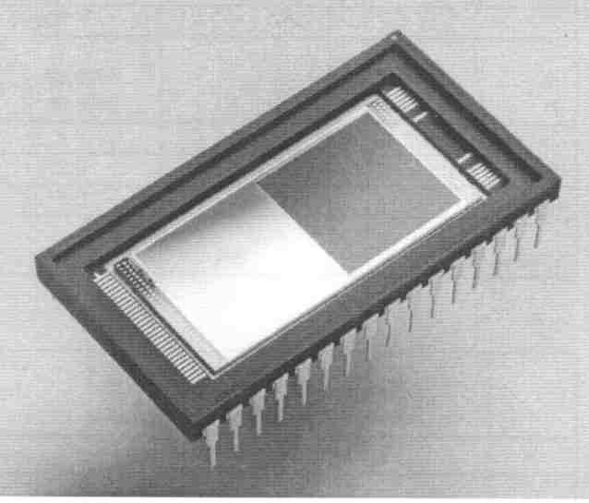
Figure 3.1. Marconi CCD47-20 sensor

Table 3.1
λ, μm | Filter | Science goals | Brightness ^{*)} | Filter bandpass, μm | CCD quantum efficiency | CCD counts, e⁻/s
0.23 | F1 | NO nightglow | 4000 R | 0.06 | 0.5 | ~100
0.26 | F2 | SO₂ band | 50,000 | 0.01 | 0.3 | 1.2 10⁷
0.36 | F3 | Unknown UV absorber | 160,000 | 0.01 | 0.5 | 9 10⁷
0.5 | F4 | O₂ nightglow | 2500 R | 0.1 | 0.8 | 100
0.97 | F5 | H₂O below 10 km | 20 | 0.02 | 0.2 | 10⁵
1.02 | F6 | Surface | 50 | 0.05 | 0.05 | 7 10⁴
^{*)} The measured brightness in this column is expressed either in [erg/s/cm²/μm/sr ] or in R (Rayleigh). The latter case is explicitly marked by letter “R” at the number. 1 R is equivalent to emission of 10⁶ photon/cm²/s into 4π steradian.

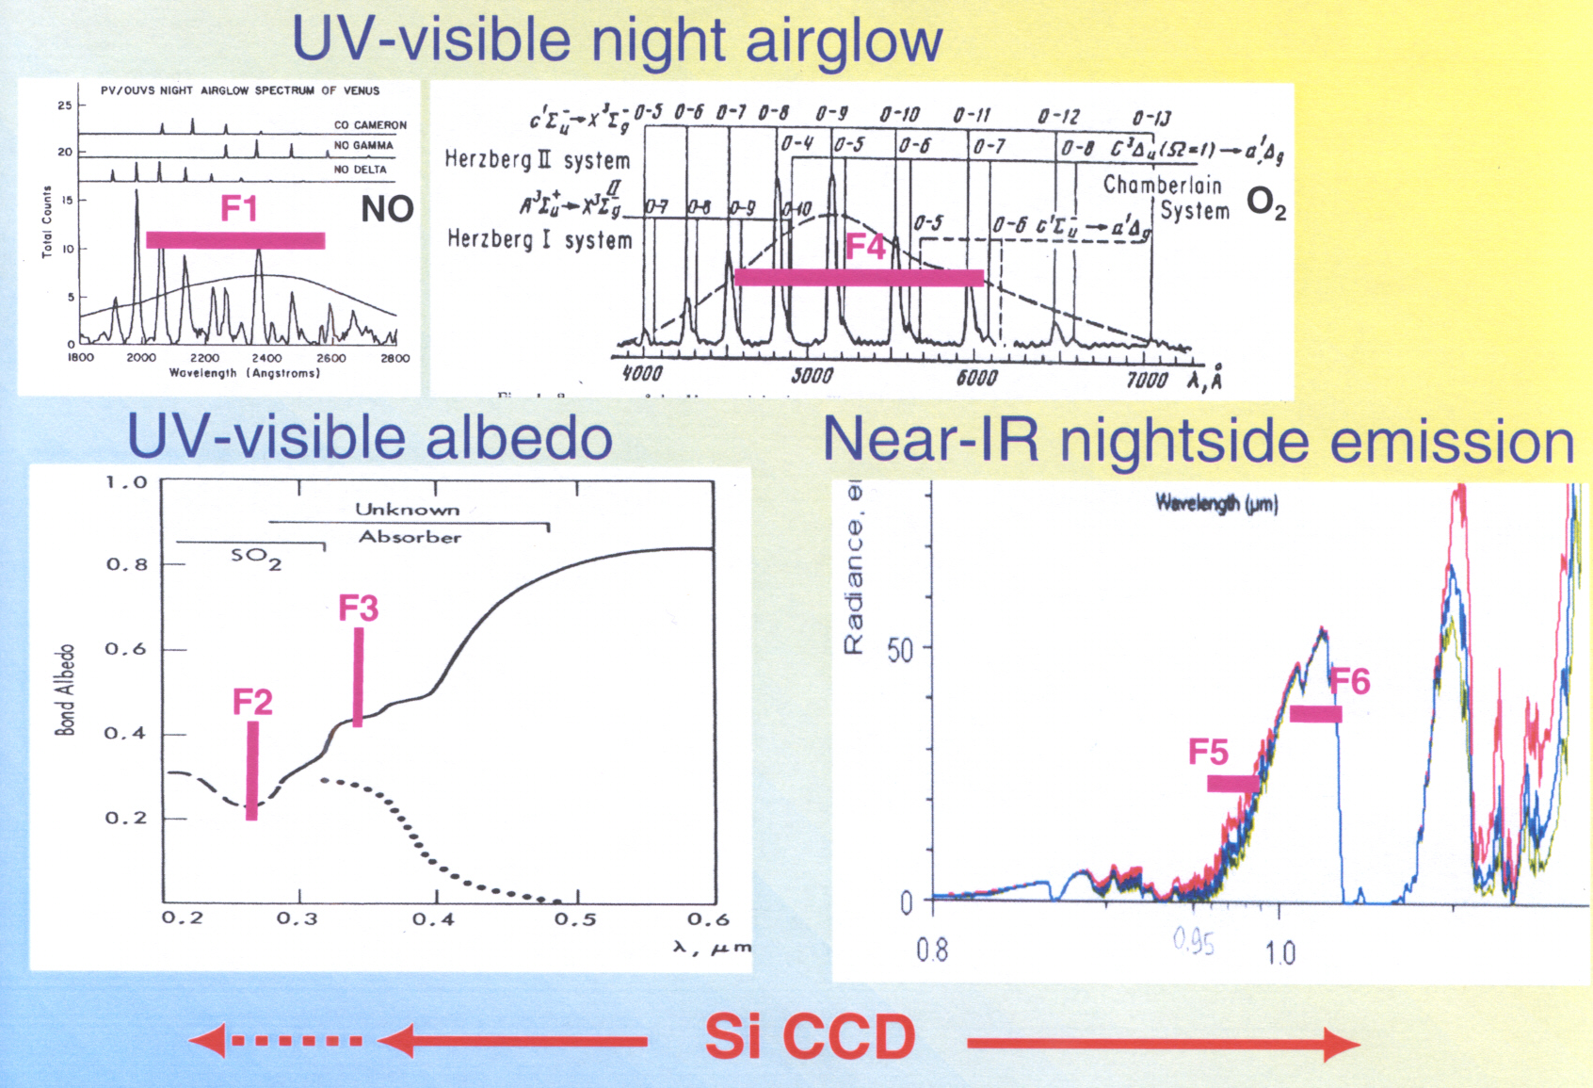
Figure 3.2. Positions of the camera filters with respect to the spectral features of interest.

3.2 Angular resolution requirements
The optical requirements to the camera are defined by the main goal of global monitoring. This means that near the apocenter (20,000-30,000km) the whole Venus disc should be in the field of view. Thus the total field of view should be about 30° (~1 rad). The size of smallest UV features observed so far does not exceed 100km. Thus, the camera spatial resolution of ~30 km/px in the apocenter (30,000km) would be sufficient. Surface imaging in the 1μm “window” does not require better spatial resolution since the scattering in the clouds anyway reduces surface contrasts to a size of several tens of kilometers. In the pericenter (~250 km) this would correspond to the spatial resolution of few hundreds of meters.

3.3 Camera design

3.3.1 CCD detector
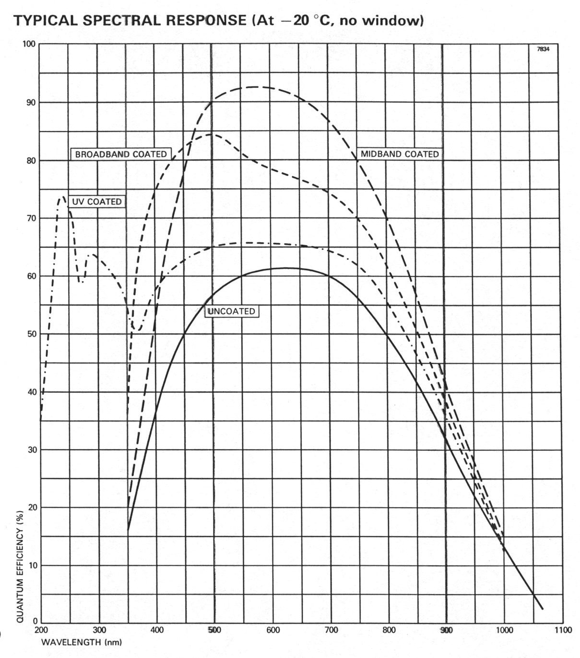
Figure 3.3. CCD spectral response.
The UV coated backthinned frame transfer CCD (Marconi Applied Technologies Ltd) with 1024x1024 pixels will be used in the Venus Express camera (Figure 3.1). These sensors provide the necessary sensitivity from 0.2 μm to 1.05 μm (Fig. 3.3). Similar CCDs were used for the OSIRIS/Rosetta cameras.
The size of individual pixel is 13x13 μm. The peak signal (fullwell) is 10⁵ e⁻/pixel and the readout noise is 2 e⁻ r.m.s. Dark signal for this CCD at t~-20C is about 1e⁻/s/pixel. Total noise level is expected to be less than 5 e⁻ r.m.s.. The detector has optimal operational temperature of ~ -40°C.

3.3.2 Optical scheme

Figure 3.4. Layout of the Venus Express camera
The camera has six spectral channels listed in the Table 3.1. In order to avoid moving parts in the instrument it is proposed to use six lenses and filters instead of a filter wheel. The lenses create all six images on two CCDs simultaneously. Figure 3.3.2 shows the layout of the instrument. Filters F2 and F3 (UV-blue spectral range) will work on the dayside, while the other filters will be operating at the night side (airglow and 1μm “window” emission). About one quarter of the 1024x1024 CCD image area (i.e. 512x512) is occupied by each image. This results in angular resolution of ~1mrad/px in order to provide the needed spatial resolution (see section 3.2).

3.3.3 Temperature requirements
Optimal working temperature of the CCD detector is about –40C. So the camera requires cooling that could be provided by a small radiator.

3.3.4 Instrument resources
The mass of the optics, CCD detectors assembly, and electronics shown in Fig. 3.4 is about 0.5 kg. The instrument will also include a power supply and a radiator which mass will depend on the location of the instrument on the bus. However, in any case the total mass of the camera will not exceed 1 kg. The volume of the instrument will be less that 1 dm³, and the power consumption will be 3-4 W.

3.3.5 Experimental heritage
The Venus Express camera will benefit from broad experience in designing and building of CCD-based cameras gained at MPAe. In the past MPAe provided the camera for Giotto mission to comet Halley and was responsible for the CCD detector modules of the cameras on Mars Pathfinder and Mars Polar Lander. Now MPAe leads the OSIRIS camera experiment onboard Rosetta mission and the microscope for Beagle-2/Mars Express.

3.4 Observations at Venus
Since the main goal of the Venus Express camera is to monitor global scale dynamical processes in the Venus’ atmosphere, the main mode of observations will be the imaging in the vicinity of apocenter when the whole planet’s disc is in the field of view of the camera. At the dayside the images will be taken in two UV-blue filters to observe the UV markings. Four filters will be used at the nightside for mapping the nightglows, surface and water vapour in the lower atmosphere. Assuming the use of 12 bits/pixel conversion one image is ~ 3 Mbits of data. Data compression will decrease this number by a factor from 2 to 8 depending on the compression algorithm used. Velocity of the cloud motions is about 300 km/hour, or ~10 pixels/hour. Typical time scale of the airglow pattern variations is ~1hour. Thus taking 10 images (2 images/hour) at the apocenter would give representative set of data. This would result in the data rate of ~60 Mbit/orbit at the day side and 120 Mbit/orbit at the nightside without compression.

4 Management and planning

4.1 Cost estimates

4.2 Planning and responsibilities

5. Team experience
Dr. H.U. Keller(MPAe) – camera observations of comets and planets (Giotto, Mars Pathfinder, Mars Polar Lander, Rosetta, Mars Express missions);
Dr. W.J. Markiewicz (MPAe) – camera experiments on the Mars Pathfinder, Mars Polar Lander and Mars Express missions;
Dr. N. Thomas (MPAe) – camera and spectroscopic observations of planets and comets (Mars Pathfinder, Mars Polar Lander, Beagle-2/Mars Express, ground-based observations);
Dr. D.V. Titov (MPAe) – spectroscopic, spectro-imagimg and camera observations of Venus and Mars (Venera-11, -15, Phobos, Mars Pathfinder, Mars Express);
Prof. F.W. Taylor (Oxford University) – radiometry, imaging radiometry and imaging spectroscopy of Venus and Mars (Pioneer Venus, Mars Climate Orbiter, NIMS/Gallileo), radiative balance and dynamics of the Venus atmosphere;
Dr. E. Lellouch (Observatoire de Meudon, Paris, France) – groundbased infrared and microwave observations of Venus and Mars, dynamics of the planetary atmospheres;
Prof. L. Esposito (University of Colorado, USA) – UV spectroscopy of planets (Pioneer Venus, Cassini), composition of the Venus atmosphere;
Prof. D. Crisp (JPL, NASA, USA) – ground-based spectro-imaging of Venus, radiative transfer;
Dr. N. Ignatiev (Space Research Instritute (IKI), Moscow, Russia) – composition of the Venus atmosphere, radiative transfer;

References
Allen, D. and J.W. Crawford, Cloud structure on the dark side of Venus, Nature 307, 222-224, 1984.
Baines, K. et al., Detection of sub-micron radiation from the surface of Venus by Cassini/VIMS, Icarus 148, 307-311, 2000.
Crisp D. et al., Ground-based near-infrared observations of the Venus nightside: 1.27 μm O₂ (α¹Δ_{g}) airglow from the upper atmosphere, J. Geophys. Res. 101, nE2, pp. 4577-4593, 1996.
Galileo images of Venus in UV.
Krasnopolsky, V.A., Venus spectroscopy in the 3000-8000  region by Veneras9 and 10, in Venus-I book, p.459, 1983.
Meadows, V.S. and D. Crisp , Ground-based near-infrared observations of the Venus nightside: the thermal structure and water abundance near the surface, J. Geophys. Res. 101, nE2, pp. 4595-4622, 1996.
Moroz, V.I, et al., Solar and thermal radiation in the Venus atmosphere, Adv. Space Res. 5, n11, pp.197-232, 1985.
Stewart et al., Morphology of the Venus ultraviolet night airglow, J. Geophys. Res. 85, nA13, pp. 77861-7870, 1980.

